Cairo University Faculty of Computers and Information



**CS352 – Software Engineering II**

**Software design specification document**

**2019**

**Project Team**

|  |  |  |  |
| --- | --- | --- | --- |
| **ID** | **Name** | **Email** | **Mobile** |
| 20160086 | Gomaa ebed mohamed | kkrem551@gmail.com | 01024860841 |
| 20160054 | Eslam said taha | Eslamsaid2391998@gmail.com | 01146124184 |
| 20160170 | Amr Mohamed fahmy | amrfahmy3210@gmail.com | 01148593387 |

**[Marwa Mohamed]**

[semi_coulmn,quiz]

**[Mohamed ramadan]**

# Class diagram design

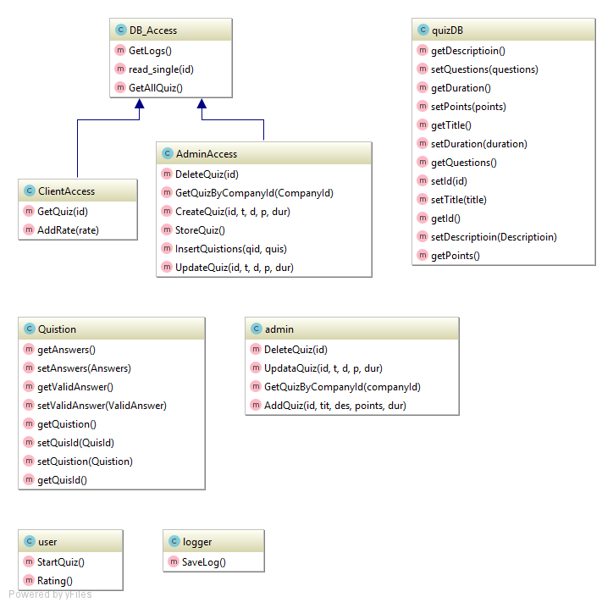

# 

# ERD design

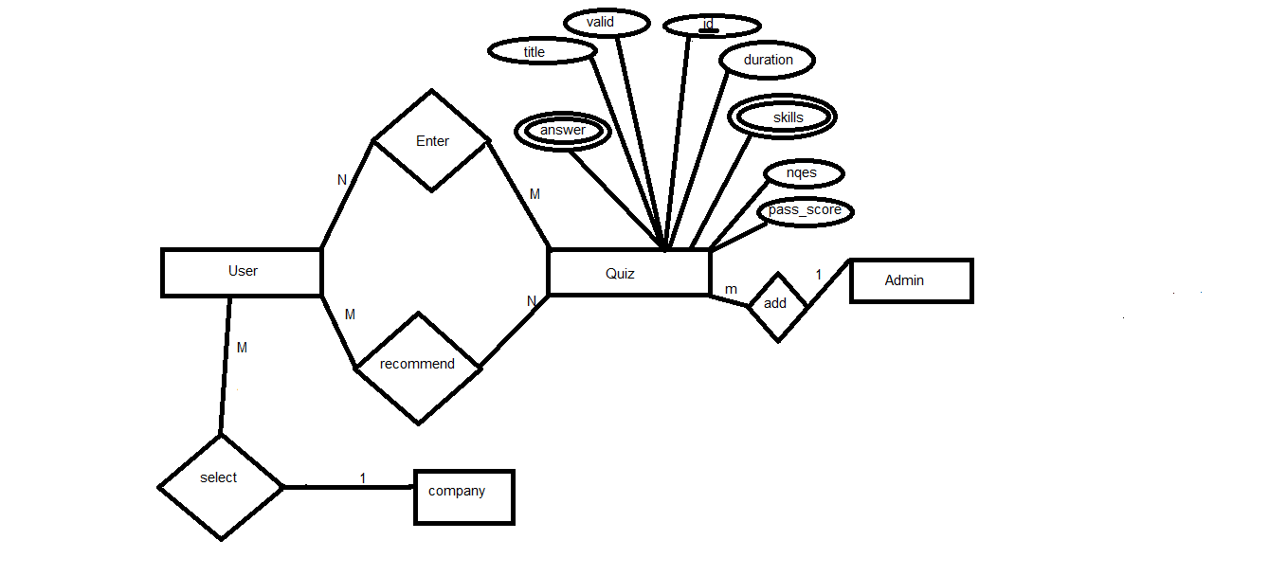

# Github repository link

[https://github.com/Gom3a98/Quiz](https://github.com/Gom3a98/Quiz?fbclid=IwAR2rlmeIC5eIL6dzdhmtGWq0ZhR43zHYnxQmvqK42_4FIhMMAQBaFeYY63o)

# Trello WorkSpace link

https://trello.com/b/chfsc0EO/general

Docker image is located in newB branch on github